
You spend a lot of time making sure your flyers, brochures, and invites, etc. are pleasing to the eye, but can everyone access them?

Five Habits for Creating Accessible Documents

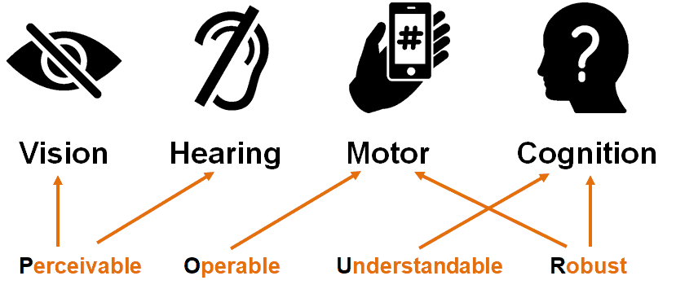
Now more than ever, the need to create accessible documents is at the forefront of our minds. Twenty-six percent of adults in the United States have some type of disability that could create a barrier that affects their ability to access digital information.
This free webinar offers highly actionable advice that you can instantly incorporate into your day-to-day workflow to assure your document is readable by individuals with disabilities.
For More Information:
www.katsnet.org
Topics Covered:
• fonts,
• layout,
• images,
• styles,
• tables,
• built-in accessibility tools
Register: (fields in RED required)
Name
Email Address

